**Technology in the Music Classroom Lesson Plan Assignment**

**Name: Amber Kuykendall**  **Lesson Plan Type: Connecting**

**Lesson Title/Description: Music: The Universal Connection/ Connecting music to past and current events and emotions.**

**Class/Grade:** Concert Band (11-12th Grade)

**Lesson Time:** 50 minutes

**Standards:**

* MU:Cn11.0.8a Demonstrate understanding of relationships between music and the other arts, other disciplines, varied contexts, and daily life
* MU:Pr4.3.8a Perform contrasting pieces of music, demonstrating as well as explaining how the music’s intent is conveyed by their interpretations of the elements of music and expressive qualities (such as dynamics, tempo, timbre, articulation/style, and phrasing).
* MU:Pr4.2.8c Identity how cultural and historical context inform performance and results in different musical effects.

|  |  |
| --- | --- |
| **Learning Outcomes** | **Assessment Evidence** |
| By the end of this lesson, students will recognize common emotions in response to “Fight On” | Evidence: “Fight On” Word cloud |
| By the end of this lesson, students will know the history and main themes of Finlandia. | Evidence: Completed Google form with 80% of questions answered correctly. |
| By the end of this lesson, students will understand the message of Finlandia | Evidence: Finlandia Word cloud. |

**Prior Knowledge and Skills:**

Students know how to read standard music notation.

Students know how to use smart devices for mentimeter.

Students know how to access and complete google forms.

**Materials:**

* SmartBoard to display presentation.
* 5-minute YouTube countdown timer <https://www.youtube.com/watch?v=_W0bSen8Qjg>
* Full Band Warm Up sheet music
* Finlandia sheet music
* The Harlem Gospel Singers “Fight On” <https://youtu.be/M7cRAvPZmGo>
* Smart Devices
* Mentimeter Word Wall Presentation
* Finlandia history video: <https://www.youtube.com/watch?v=lDge39yU8p0>
* Google Form: <https://forms.gle/DUjMiRWmyJWKpWcdA>

**Learning Activities:**

1. Students come in, receive the new Finlandia sheet music from the section leader, and take their seats with their smart devices (no instruments, 5 minutes). <https://www.youtube.com/watch?v=_W0bSen8Qjg>
2. After the warmup and tuning is complete, the teacher will ask students to lower their stands to discuss connecting music to events. The teacher will ask students to raise their hands if they have heard of the name George Floyd. The teacher will call on students to share what they remember. (5 minutes)

The teacher will add that: “George Perry Floyd Jr. was an African-American man who was murdered by a police officer in Minneapolis, Minnesota, during an arrest made after a store clerk suspected Floyd may have used a counterfeit twenty-dollar bill, on May 25, 2020” (Wikipedia).(2 minutes)

1. The teacher will say:

“We are about to listen to a song that was written one year ago. It references the acts and words spoken by Floyd in the minutes leading up to his death. I want you to listen to this song and think about the different emotions you feel as the song progresses and is played. At the end of the song, we will create an emotion word wall. Remember to be respectful of each other, and kind.

IMPORTANT: PAUSE THE VIDEO AT :40, AND RESTART IT AT :48 (inappropriate language on protest sign)

[The Harlem Gospel Travelers - Fight On! [OFFICIAL VIDEO]](https://www.youtube.com/watch?v=M7cRAvPZmGo)

[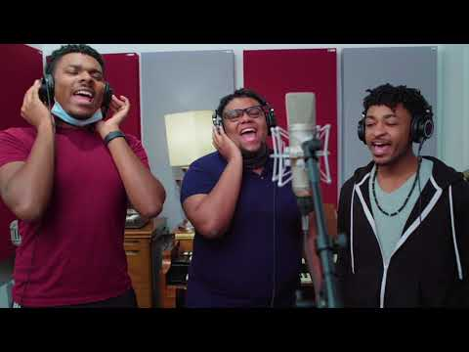](https://www.youtube.com/watch?v=M7cRAvPZmGo)

(5 minutes)

1. The teacher will switch to the mentimeter tab on the presentation. The teacher will then have students open their smart devices, go to www.menti.com and enter the code on presentation (the code expires in two days so it is always new). Students will enter up to three responses, answering this question:

“What final emotion do you feel after listening to Fight On?”

After responses are entered and displayed, the teacher will point out the common responses and tell students that these common responses connect us to each other, and music is known as a universal connection, something that everyone can share and experience together. (5 minutes)

1. The teacher tells students:

“Our new music that we will be working on, Finlandia is like Fight On, only it happened over one hundred years ago, in 1899. It is an anthem that represents struggle, freedom, and hope. Listen closely to this video because we will have a google form to complete about the history of Finlandia before the end of class.”

The teacher switches the tab back over to YouTube and shows Finlandia video. [FINLANDIA by Jean Sibelius - Music History Crash Course](https://www.youtube.com/watch?v=lDge39yU8p0)

[](https://www.youtube.com/watch?v=lDge39yU8p0)

(15 minutes)

1. The teacher will switch tabs back to the Menti presentation. Students will submit up to three responses, answering this question:

“What emotions do you feel after listening to the ending of Finlandia?”

Once responses are all received, the teacher will go over most common responses.

(5 minutes)

1. The teacher will thank students for their respectful responses. Lastly, the teacher will have students complete this google form about the history of Finlandia. The teacher will tell students that they can work together in their instrument section to complete the form. (10 minutes)

<https://forms.gle/DUjMiRWmyJWKpWcdA>