Technology in the Music Classroom Lesson Plan Assignment
Name: Amber Kuykendall Lesson Plan Type: Responding

Lesson Title/Description: Music makes me feel../ Experiencing music through movement, active listening, and drawing.
Class/Grade: Group Piano/ 1st grade
Lesson Time: 45 minutes
Standards:
- MU:Re9.1.1a With limited guidance, apply personal and expressive preferences in the evaluation of music for specific purposes.
- MU:Re8.1.1a With limited guidance, demonstrate and identify expressive qualities (such as dynamics and tempo) that reflect creators’/ performers’ expressive intent.
Learning Outcomes | Assessment Evidence
By the end of this lesson, students will be able to analyze the main musical feeling of a song.  Students will actively listen to the William Tell Overture  Students categorize different sections of the William Tell Overture. | Evidence: Students will put tally marks on board of musical feeling after discussing with their neighbor.  Evidence: Student groups create and present their musical tableaus.  Evidence: Students sort through the music map and correctly identify each section at the specified time.

Prior Knowledge and Skills:
Students know how to operate iPads and headphones.

Students know how to express rudimentary emotions: happy, sad, excited, scared, nervous.

Students know how to work successfully in groups.
Materials:
- SmartBoard to display videos and presentations.
- Dance of the Sugar Plum Fairy https://www.youtube.com/watch?v=eyC4D3RKDx4
- William Tell Overture listening map https://www.youtube.com/watch?v=DVDVpEPSqTY
- Inside the Orchestra Music Maps sorter https://insidetheorchestra.org/outside-the-orchestra/music-maps/
- Ipads
- Headphones
- Musical Paint for Kids App (Demo video: https://youtu.be/6Ng_N3fSCLw )

Learning Activities:
- Introduction: Students should begin this lesson seated on the floor. We discuss the different feelings that we can feel when listening to and experiencing music. Sentence stem: “Music makes me feel...” is written out on the board. The teacher will then list each feeling out on the board. (5 minutes) The teacher will say:
“As we do different activities, listen to what your head is saying and read the different feelings on the board. Which one matches? We will put tally marks next to what each person is feeling for each activity.”
- Students will be instructed to stand up, the teacher will say:
“We are about to move to the music with our own secret sugar plum fairy, but first we have to create them in our minds! Close your eyes, no peeking! Think about what color hair your fairy has, decide if they will be a boy fairy or girl fairy, think about what they will be wearing. Open your eyes and thumbs up when you find your fairy. We must be quiet! Or the fairy will get scared and turn invisible. Dance Of The Sugar Plum Fairy
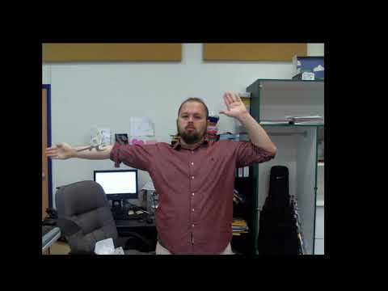

(7 minutes)
- After the sugar plum fairy dance, the teacher will say:
“Wonderful secret fairy dances! How did that music make you feel? Turn to your neighbor and talk about your main feeling.” (30 seconds).
“Great job talking about your music feelings. I will be calling on five quiet students sitting criss cross apple sauce to put a tally mark next to their main music feeling on the board.” (2 minutes, 30 seconds).
- The teacher will say:
“Next, we will have some new music with a different feeling, it is called the William Tell Overture. And instead of using music notes to track the beat, we use different images like horses, and horseshoes! Now, each image shows us a different musical sentence or idea, we call this a musical phrase. Watch closely for all the different images! (5 minutes). William Tell Overture Listening Map
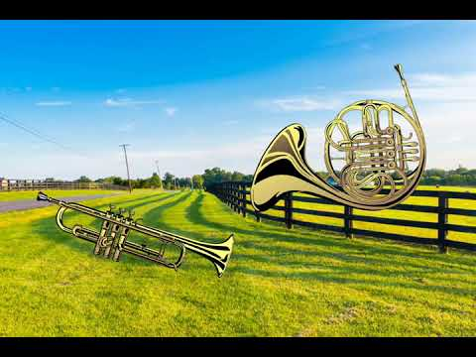
After the video the teacher will say:
“Wow, I saw some excellent listening ears from (student 1, and student 2) Thank you! Now, turn to your neighbor and tell them 2 things: Your favorite music image, and how the music made you feel!” (1 minute)

The teacher continues: I will be calling on five quiet students sitting criss cross apple sauce to put a tally mark next to their main music feeling on the board. (2 minutes)
- Break students into groups: Create a Tableau or freeze frame! Display this photo on projector as an example: 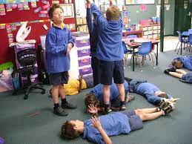

The teacher says: “Okay students, we will be listening to the William Tell Overture again. This time you must create a musical scene using your group members, here is an example (points to screen). You must decide WHAT you are going to tell with your scene. Activate those listening ears. You will have 4 minutes AFTER the song finishes to figure out what you want to create.”
Teacher plays video, monitors groups. (7 minutes).
Each group then presents the tableau, quiet students are chosen first. “Remember class, we listen with open ears, and a closed mouth.” (5 minutes).
- Students return to their spots. The teacher says “who remembers what the William Tell Overture sounds like?” waits for students to raise hands. “Okay guys, we are going to listen to the overture one last time. This time we have to sort a musical map into the correct order. The teacher displays the musical map and goes over each square section: https://insidetheorchestra.org/outside-the-orchestra/music-maps/
Class works through musical map; the teacher pauses at each section to lead the group and eliminate some answer choices.
“Amazing listening ears! You completed the whole map together as a group. As your reward we will be drawing with musical sounds for our last activity. Quiet students sitting criss cross applesauce will be chosen first. (8 minutes)
7) Teacher instructs students to bring out their iPad. As students bring out iPads, headphones are plugged in. Students go to “Musical Paint for Kids App”. Spends last (7 minutes) drawing. Here is a video of what it sounds like. Musical Paint - Best App For Kids - iPhone/iPad/iPod Touch
