Technology in the Music Classroom Lesson Plan Assignments
Name _Alex Gil_____________________ Lesson Plan Type ___Responding to Music____

Lesson Title/Description: Hungarian Dance No. 5 by Johannes Brahms
Class/Grade: 3rd Grade general music
Lesson Time: 45 minutes
Standards:
MU:Re7.2.3a Demonstrate and describe how a response to music can be informed by the structure, the use of the elements of music, and context.
MU:Re8.1.2a Demonstrate and describe how the expressive qualities are used in performers’ interpretations to reflect expressive intent.
MU:Re9.1.3a Evaluate musical works and performances, applying established criteria, and describe appropriateness to the context.

Learning Outcomes | Assessment Evidence
By the end of this lesson, students will know some basic facts about Johannes Brahms’ life. | Evidence: Success is when the student can recall some of the information presented about Brahms’ life in discussion.
By the end of this lesson, students will be able to  Evaluate a musical performance using appropriate vocabulary. | Evidence: Success is when the student can write 1-2 sentences evaluating a musical performance and through discussion.
By the end of this lesson, students will be able to  Respond to musical structure through locomotor and non-locomotor movement. | Evidence: Success is when each student can engage in locomotor and non-locomotor movement reacting to structural changes in a musical performance.

Prior Knowledge and Skills:
- Students must already know different locomotor or non-locomotor movements.
- Students must already know grade appropriate music vocabulary dealing with pitch, dynamics, tempo, and musical style.
Materials:
- Student Chromebooks
- Teacher Computer
- Projector
- Sound system.
- Google Form exit ticket link

Learning Activities:
- Teacher will begin class with an introduction to Johannes Brahms.
- Students will watch the following short youtube video about the life and work of Johannes Brahms.
- https://www.youtube.com/watch?v=t_L93v6AIsM
- Teacher will lead discussion asking guiding questions to students to check for understanding.
- Teacher will open the paid subscription website Essential Elements Music Class.
- https://www.eemusicclass.com/ (actual login omitted due to copyright)
- Teacher will click resources and then listening maps.
- Teacher will click on “Hungarian Dance No. 5” with answers checkbox checked.
- 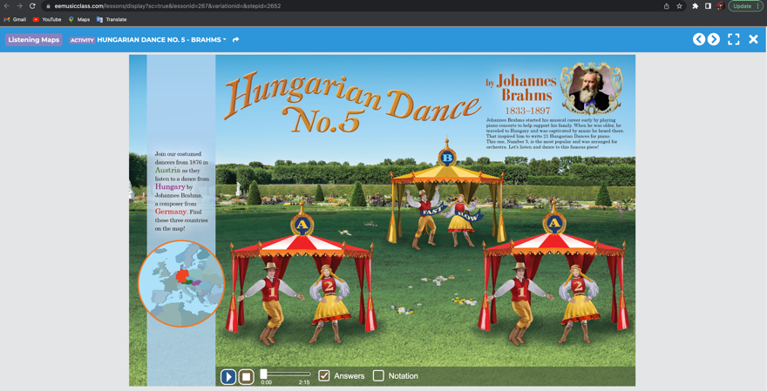
- Teacher will click play asking students to listen for differences in the different themes and sections of the music.
- As a class students will use the movement word wall (word wall in the back of classroom with locomotor and non-locomotor movements such as stretch, jog, tip toe, shrink, wiggle, etc.) Students will select a different movement for each theme in the piece.
- Students may try different options until we come to a class concensus.
- Teacher will play the listening map piece again this time with the full class performance.
- Teacher will play the following video performance of the piece.
- https://www.youtube.com/watch?v=ynCEvFaJCZg
- Students will fill out the following Google form as an exit ticket where they will describe some expressive qualities of the performance.
- https://docs.google.com/forms/d/e/1FAIpQLSdDepfWS7isFjq2mCgTQwwOupw2Bikarfgk_EPFKowgcbovtQ/viewform?usp=sf_link

